**Front End Engineering II**

**Project Report**

**Semester-IV (Batch-2022)**

**Currency Converter using Tailwind CSS**

|  |  |
| --- | --- |
| **Supervised By:**  **Mr. Raveesh Samkaria** | **Submitted By:**  **Tanish dalal**  **2210990888**  **G13(B)** |
|  |  |

**Department of Computer Science and Engineering**

**Chitkara University Institute of Engineering & Technology,**

**Chitkara University, Punjab**

# **Abstract:**

In the dynamic landscape of web development, user experience stands as the cornerstone of success. Blurry loading animations emerge as a captivating tool, enriching the user journey by offering visual engagement during page load times. This innovative technique combines the simplicity of HTML, the elegance of Tailwind CSS, and the interactivity of JavaScript to seamlessly integrate loading animations into web projects.

HTML provides the foundation, offering a straightforward structure for embedding elements. Tailwind CSS steps in with its comprehensive utility classes, enabling swift styling and customization without sacrificing efficiency. Meanwhile, JavaScript adds interactivity, allowing for dynamic updates and enhanced user feedback.

By delving into the implementation process, developers can harness the power of these technologies to craft loading animations that not only captivate users but also contribute to a seamless browsing experience. With concise guidance and essential code snippets, this approach empowers developers to elevate user satisfaction and enrich the overall quality of their web projects, establishing a compelling digital presence in today's competitive online landscape.

# **Introduction:**

In today's fast-paced web development landscape, where user attention is fleeting and expectations are sky-high, crafting a seamless and engaging user experience is imperative. One aspect gaining increasing focus is the loading experience of web pages. While traditional loading spinners and progress bars serve their purpose, they often fall short in captivating users or providing meaningful feedback during the loading process.

To bridge this gap, developers are turning to innovative approaches like blurry loading animations. These animations not only signify that content is being loaded but also offer a visually striking transition that keeps users engaged during the wait. Their popularity stems from their ability to enhance perceived performance and overall user satisfaction.

Throughout this exploration, we'll delve into the rationale behind adopting blurry loading animations, the advantages they bring, and effective implementation strategies in web projects. By grasping these principles and techniques, developers can elevate the loading experience of their websites, contributing to a more enjoyable browsing journey for users.

# **Significance:**

1. **Enhanced User Experience**: Implementing a blurry loading animation significantly improves the overall user experience by providing visual feedback and reducing perceived wait times. This enhanced experience can lead to higher user satisfaction and increased engagement with the website.
2. **Improved Perceived Performance**: Blurry loading animations create the illusion of continuous activity, even during longer loading times, thereby improving perceived performance. Users are more likely to perceive the website as responsive and efficient, leading to a positive impression of the brand or service.
3. **Reduced Bounce Rates**: Engaging users with a visually appealing loading animation can reduce bounce rates, as visitors are more likely to stay on the page while content loads. This can result in longer session durations and increased opportunities for conversion or interaction.
4. **Competitive Advantage**: In a competitive online landscape, providing a seamless and enjoyable user experience sets websites apart. By implementing a blurry loading animation, websites can differentiate themselves from competitors and leave a lasting impression on visitors, ultimately driving user loyalty and retention.

# **Problem Statement:**

The traditional methods of currency conversion often involve manual calculations or reliance on outdated 000conversion tools. These methods can be time-consuming, prone to errors, and may not provide up-to-date exchange rate information. The Currency Converter project seeks to address these challenges by offering a centralized platform for currency conversion with real-time exchange rate updates. By providing accurate and timely information, the project aims to alleviate the difficulties faced by users when performing currency conversions.

# **Software Requirements:**

The following are the requirements for the project:

## **HTML:**

HTML serves as the foundational framework for web pages, encompassing elements enclosed within tags to delineate content and layout. Adherence to standards and validation are imperative for HTML documents, guaranteeing correct syntax, structure, and cross-browser and cross-device compatibility.

## **Tailwind :**

Tailwind CSS stands out as a prominent utility-first CSS framework, simplifying the styling of web applications. In contrast to conventional CSS frameworks dependent on pre-built components, Tailwind adopts a highly adaptable approach by furnishing an extensive library of utility classes. These classes cover a wide range of CSS properties, including margins, paddings, flexbox, and others, empowering developers to swiftly prototype and style their applications without the need for custom CSS authoring.

## **JavaScript:**

JavaScript plays a pivotal role in web development, primarily serving as a client-side scripting language. It empowers developers to craft dynamic and interactive web pages by dynamically manipulating the Document Object Model (DOM) in response to user interactions. JavaScript grants developers the capability to dynamically access and alter HTML elements and attributes, facilitating a myriad of tasks including content updates, element creation and removal, as well as styling adjustments triggered by user actions or events.

# **Project Design:**

## **Project Overview:**

The objective of this project is to create a responsive website featuring a blurry loading effect using Tailwind CSS. HTML will be employed to structure the content, while Tailwind CSS will handle the visual presentation, ensuring a seamless and captivating experience for users across desktop and mobile devices.

## **File Structure:**

The project will utilize a well-organized folder structure for efficient management and future updates.

* **Asserts:** Image used for blurry loading effect implementation.
* **index.html:** Main HTML file containing the overall website structure and content.
* **index.js:** JavaScript file containing minor interactive elements.

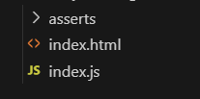

**Methodology:**

The following shows the use of HTML, JavaScript of the project.

**HTML Code:**

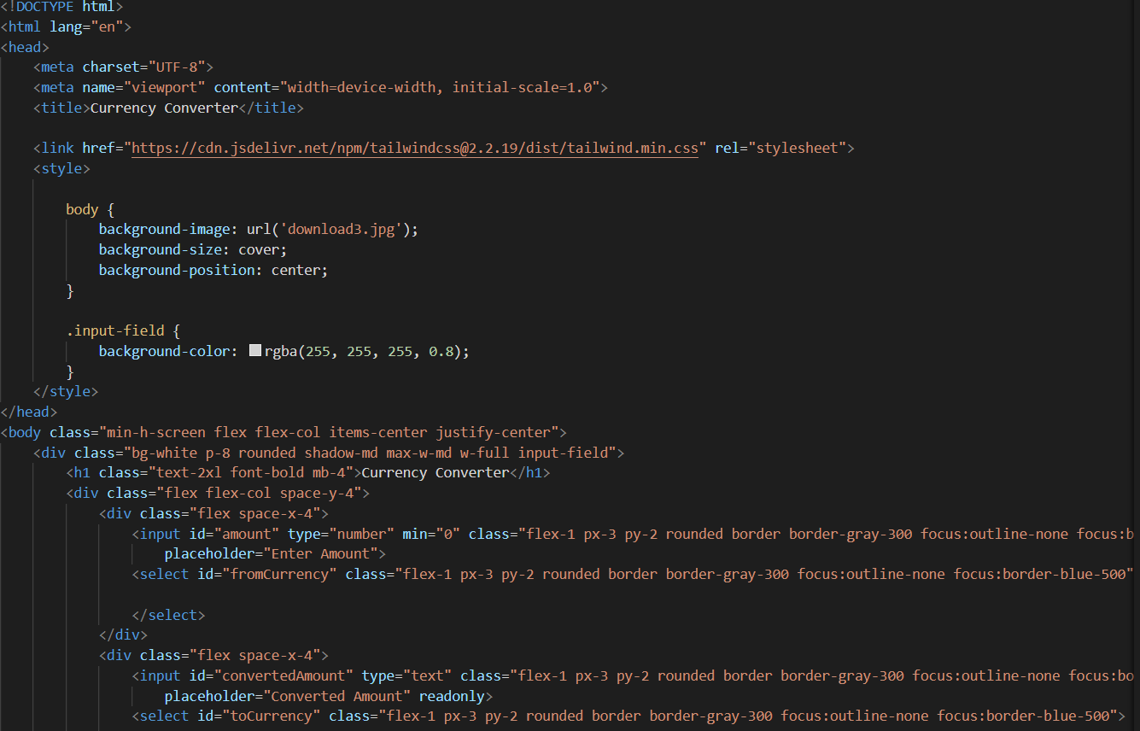

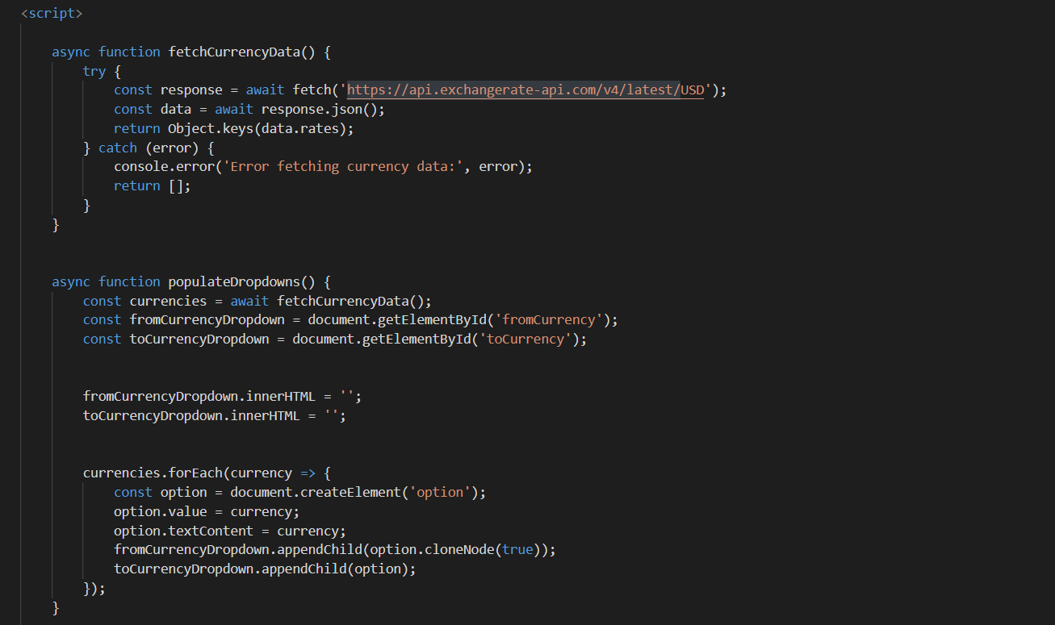

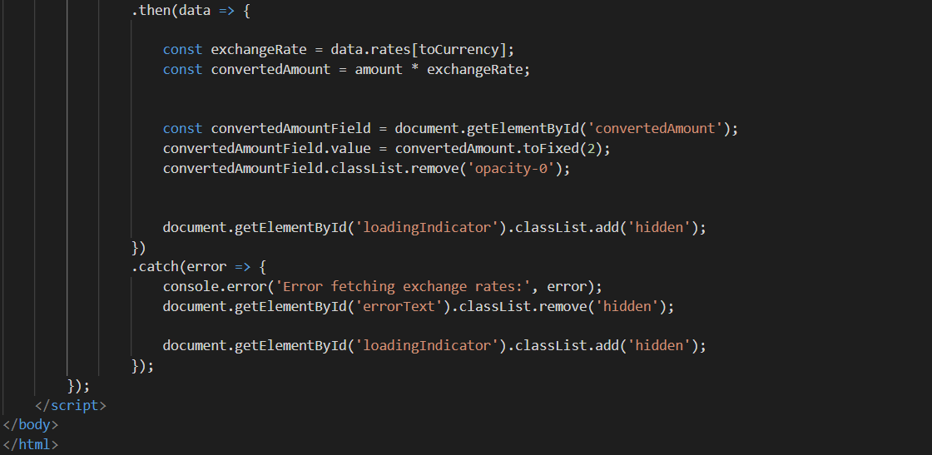

**Results:**





# **Conclusion:**

In conclusion, the implementation of a responsive website with a blurry loading effect using Tailwind CSS represents a significant step towards enhancing user experience and engagement. By leveraging HTML for content structure and Tailwind CSS for visual presentation, the project has successfully achieved a user-friendly

# **References:**

* Tailwind CSS Documentation:<https://tailwindcss.com/docs>
* Pinterest - For Images :<https://in.pinterest.com/search/pins/?q=coding%20background%20image&rs=typed>
* W3Schools - JavaScript:<https://www.w3schools.com/js/>
* W3Schools - HTML and CSS Tutorials: <https://www.w3schools.com/html/default.asp>